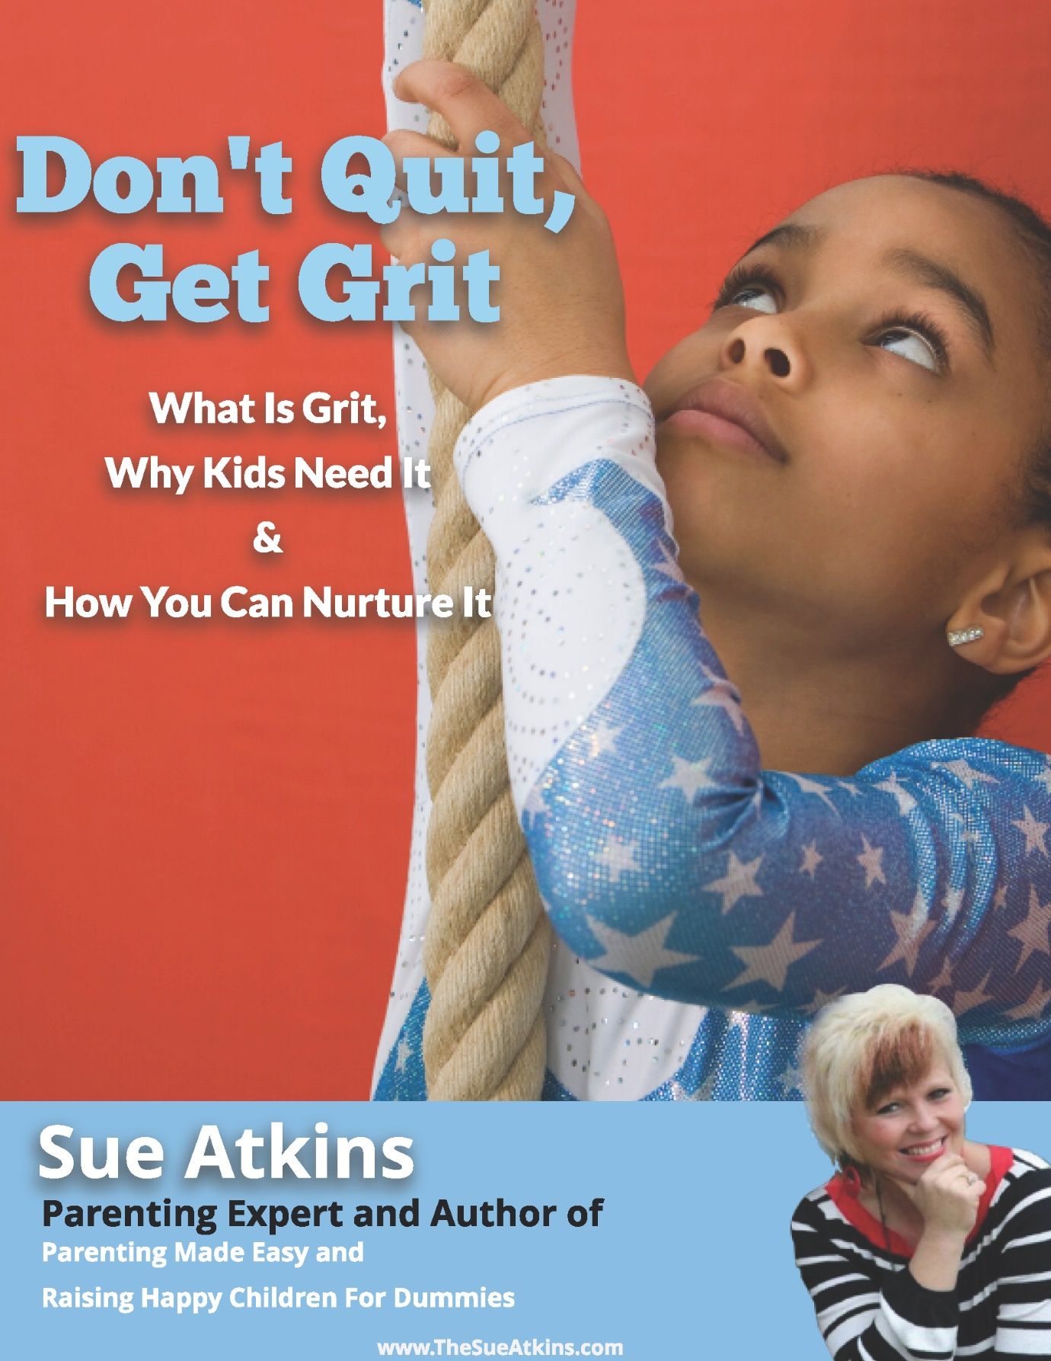

What Is Grit, Why Kids Need It and How You Can Nurture It

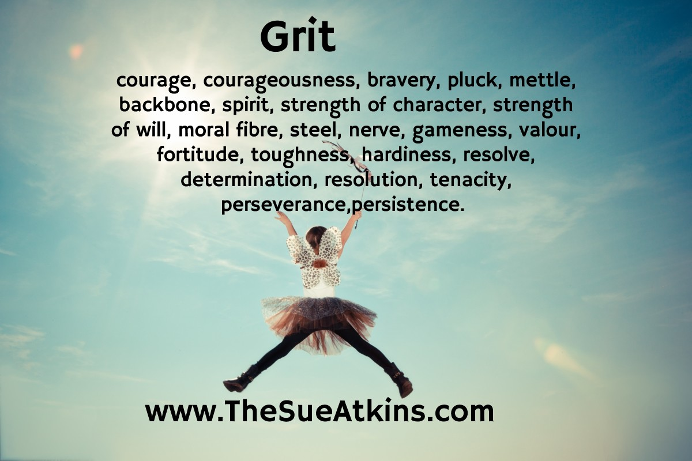

Welcome to this eBook on ‘GRIT’ for kids.
Do you hear ‘I give up’ ‘I quit’ ‘it’s too hard?’ ‘You can’t make me!’ Do they whine that it’s ‘too challenging,’ ‘too difficult’ or ‘it’s unfair’ regularly?
Then this eBook is for YOU.
Can you, or your child’s teachers, categorically predict your child’s academic success or whether your child will graduate, run their own business, achieve their dreams or fulfil their true potential?
The answer is ‘Yes’ you can, but not how you might think.
When psychologist Angela Duckworth the author of ‘Grit: The Power of Passion and Perseverance’ studied people in various challenging situations, including National Spelling Bee participants (a spelling competition in which contestants are asked to spell a broad selection of words, usually with a varying degree of difficulty) newly trained teachers in tough neighbourhoods, and West Point cadets, she found:
One characteristic emerged as a significant predictor of success. And it wasn't social intelligence. It wasn't good looks, physical health, and it wasn't IQ.
It was grit.
Grit is tenacity, perseverance, resilience and the steadfast pursuit of a task, mission, or journey in spite of obstacles, discouragement, or distraction. Grit enables someone to persevere in accomplishing a goal despite obstacles over an extended period.

My Dad
I believe I have grit and it all started when my Dad used the word ‘tenacity’ to describe me and I asked him what it meant. I think it has actually defined my life. From having to retake a couple of my ‘A’ Levels, to having to repeat one of my Teaching Practices to constantly bouncing back after disappointments both professionally and personally I get back up and try again.
I have grit.
So, this got me pondering how do we teach it to kids?
Do you model it? Do you simply just encourage your kids? Do you merely support them? Do you push them? What do you do when they falter? What do you do when they fail? What do you do when life gets tough? What do you say to help them get back up again and try again?
Just ‘Pause to Ponder’ for a moment.
How would you describe your grit?
What are your children learning from you about perseverance and tenacity?
OK, this is not about berating yourself but about becoming more self-aware, so if you don’t like what you discover don’t beat yourself up, just decide right now to make a small change that will make a big difference over time to your kid’s attitude to life.
This Ebook will help.
Discuss When You Need Grit and When You Need to Quit
Grit is not without controversy.
I agree that there is a time for grit and a time to quit. There are times when it's OK to quit something that just isn’t within your range of talents, or when trying something different may enrich your life, give you peace or take the pressure off.
The secret is to find the balance and to be self-aware enough to ponder whether you are pushing your child do something you missed out on, or wished you had achieved or stuck with, or whether they need to push through and keep going.
Worthy tasks deserve persistence. But there are tasks that would be worthier in a different season of your life. There are jobs, hobbies, dreams that should be left. Sometimes you have to let go of something good to grasp something great. Children need discernment to know when they need grit and when it may be a time to quit.

Helicopter Parenting
Helicopter parenting, coupled with the belief that we should never let our children fail, have given rise to kids who are ill-prepared to cope with life's challenges. With more research showing that ‘over involved’ parenting leads to more anxious and entitled kids, it's clear that grit and resilience will benefit your children in school, in the real world and in life generally.

Millennials-and-younger kids have grown up in a culture that celebrates overnight successes – as they’ve seen billionaire tech entrepreneurs like Mark Zuckerburg, Jeff Bezos and YouTube sensations take the world by storm overnight.
Kids today need to hear about how Harry Potter author J.K Rowling was rejected by 12 publishers before getting her first book published , how Walt Disney was fired from the Kansas City Star newspaper because his editor felt he "lacked imagination and had no good ideas" or how Thomas Edison's teachers told him he was "too stupid to learn anything" yet after that he went on to hold more than 1,000 patents and invented some world-changing devices, like the electric bulb after 1,000 unsuccessful attempts. They need to ponder Michelangelo taking 4 years to paint the Sistine Chapel or the Egyptians taking 20 years to build one pyramid.
Perhaps they need to hear more modern role models talk about Grit.
As Rita Ora recently said :
“I assert myself in things that I want to achieve, and I just don't give up." ~Rita Ora~ Musician
James Dyson who created the brilliant vacuum cleaner took 15 years and 5,126 prototypes that didn't work before he found one that did!
Ed Sheeran was mercilessly bullied at school for having ginger hair, wearing large glasses and having a port wine birth mark on his face as well as having a stutter. He picked up a guitar and stuck with it….

Steps for developing tenacity, ‘stickability,’ willpower, passion & perseverance otherwise known as ‘GRIT’ in your kids so they develop self-confidence, self-esteem & self-belief.
I’m passionate about my work to help parents be the best they can be - and it’s taken years of determination, tenacity & perseverance to get to where I am now but I still have bigger goals & bigger visions. I’ve already mentioned that I think my ‘grit’ or determination came from a conversation that I had with my Dad many years ago when he told me that I had tenacity. I asked him what that word meant, & after he explained I think he smiled, and I knew then that I had that quality & it has stood me in good stead ever since.

What is Grit & Why It’s Important.
As parents we want our kids to be happy & successful but more importantly we want them to have the resilience to get back up when they hit a hurdle or an obstacle, to bend, not break when life is difficult & challenging or disappointing.
Developing grit is not about being a famous footballer, actor or celebrity. It’s about developing the determination to master a skill, a hobby or a personal goal & to stick with it no matter what.
It’s the determination to finish not just dabble.
It’s the difference between an amateur & a master.

Grit & talent play their part as genes, personality, external influences & support play their part too, but so does psychological choices & parental influence. As parents you are your child’s primary role model so how you speak, act & model grit will be passed on to your kids consciously & unconsciously as they are watching, observing & learning from you ALL the time.

So just for this week ‘Pause to Ponder’ how you talk about perseverance & tenacity - don’t beat yourself up if you don’t like what you discover just decide to make a change.
Kids who have grit, have purpose. They are willing to go the extra mile & put in the extra effort that most kids don’t. They are like a car on a motorway following the Satnav to their chosen destination - they may pull over for a coffee break, they may encounter detours & slow traffic, but they get back on the road despite their setbacks & keep on going.
I always think of David Beckham when I think of grit, who despite his obvious talent, was the last to leave the practice pitch as he practised, practised, & practised even more. That set him apart and why he held the appearance record for playing for England as well as being revered for his skills at Manchester United with his range of passing, crossing ability and bending free-kicks as a right winger. That’s the reason they made a film called ‘Bend It Like Beckham!’

Grit isn’t about strength. It’s about endurance.
Grit is about working on something that you care about so much that you’re willing to go through anything to complete it, finish it or achieve it.
Most people chase after the next shiny thing. ‘Gritters’ stay committed to the one BIG goal & take steady small steps of action towards their big goal.
It helps to think of this concept as a race. I like to think of grit as the difference between Mo Farah & Usain Bolt. Mo is a long-distance runner who isn’t a sprinter. Usain Bolt is a sprinter who gets ahead of the pack, runs fast & furiously for a short period of time & is the winner. Mo Farah doesn’t sprint all the time as he would burn out & not be able to sustain that level of speed mile after mile. Mo exemplifies grit as he displays a steady pace, sometimes speeding up, sometimes slowing down but eventually getting to the finish line.
Both men have tremendous grit for their chosen profession but I hope you can see the analogy of sticking with something & not just giving up after a flurry of activity.

It’s the modern equivalent of Aesop’s hare & the tortoise fable!

A child who has a particularly tough day playing for his football team, missing a penalty or letting in 3 goals feels embarrassment or devastation but if that child turns up again on Wednesday night for training - he shows true grit. (John Wayne’s film springs to mind - shows how old I am!)
A child who is learning the piano but plateaus on a piece, yet keeps practising until she masters it shows grit.
In Angela Duckworth’s fascinating book ‘Grit’ she writes about the relationship between talent, grit & achievement.
Talent + Effort = Skill
Skill+ Effort = Achievement
Effort builds skill & then effort accelerates skill into achievement.

In Dr. Angela Duckworth’s book she writes about what makes the difference between students who pass out of the elite United States Military Academy, known as West Point & those who don’t - and empirically the difference is grit not ability!

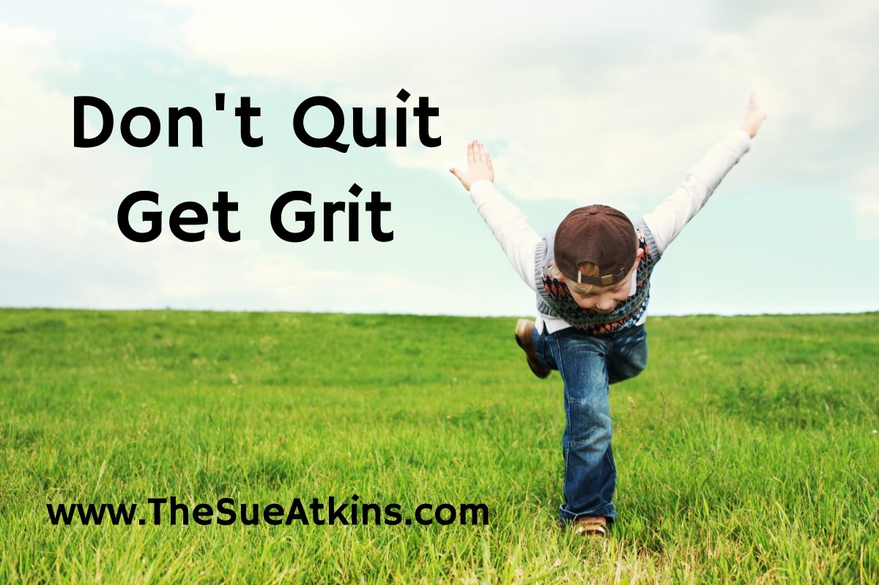

Ways to Develop Grit
We are all influenced in two ways. Internally & Externally. The way to help your kids develop grit is to help them explore & experience interests & hobbies that they enjoy. Through encouraging & supporting your kids to develop their interests & to stick with them they are experiencing the delightful experience of personal satisfaction.
Aunts, uncles, teachers, coaches, & especially you, help your child to keep going & that grows their grit from the outside - their external influence.
Developing inside grit requires you to help your child develop their own positive inside voices that are rooted in their strong self-esteem, self-belief & self-confidence.
I wrote my ‘Can Do Kid Journal’ to develop your child’s inner confidence.
Get the Journal Now

Types of Action
To get to a big goal kids need to develop middle level & low-level small steps of action.
Low level goals are short term, bite sized small steps that are specific.
To learn to play the piano well for example a child needs to practice for 30 minutes every day at 6 o’clock - that goal is specific, regular & achievable with good organisational skills. It leads to the bigger goal of being a confident & competent piano player over time.
Mid-level goals are made up of several low-level goals. All building on each other - like the Egyptians building the pyramids. One stone block at a time over a long period.
High Level goals are the big ones – the long-term ones – the ones that make you excited and motivated to keep going and to keep trying.

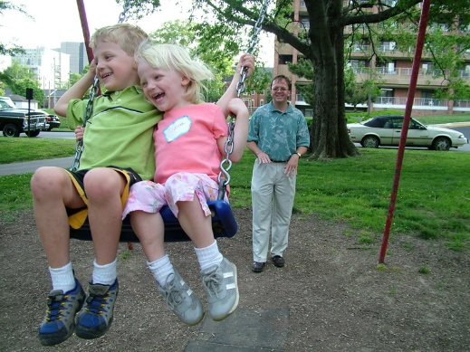

Finding Passion
Helping your child to find something that they can get excited about and passionate about may take time. Children need to experience lots of hobbies or interests before they find one that lights the fire of their imagination.
Passion is ignited also by becoming good at something by sticking with it. Lots of adults dabble at golf but when they plateau they give up & dabble at another activity like squash.

The secret is to find that balance between plateauing & pushing through to getting good at something.
It takes hard work & lots of practice at the beginning of starting out learning something new. It’s similar to a rocket launching from Cape Canaveral - it takes lots of energy & fuel to launch into space but less to stay there.
To help your child stay with a hobby or a sport, encourage them to look at specific things to practice or improve - it helps to keep them motivated as the bigger goal is broken down into smaller specific bite size bits.
Lots of gritty people develop a purpose bigger than themselves. Elon Musk, Bill Gates, Jeff Bezos focused on solving big problems & their charity work also focuses on solving big problems for humanity. It sustains their passion & purpose to make a difference & to leave a legacy behind them.

An Optimistic Attitude
Developing an optimistic attitude to life is also a great motivator.
Children who expect their goal to come true by working hard and taking more small steps consistently over time, who expect setbacks but have resilience to get back up after a disappointment & try again, who believe that they make their own luck & take responsibility for their own actions fair far better in succeeding as it’s this grit & determination that makes the difference.

Growing Grit
One simple way to develop your child’s grit is to ‘Talk & Teach’ them about staying with something ‘just a little bit longer’ - stay in their Art Club just for another week, struggle to tie their shoelaces for ‘just for a little bit longer’ listen to the French audio podcast ‘just a little bit longer’ stick with their homework ‘just a little bit longer’
Build tenacity through developing this ‘just a little bit longer’ mindset.
Get your kids to design a poster and pop it up on your kitchen fridge to remind everyone of this mindset to developing Grit.

The Growth Mindset
I always talked to my kids about how amazing their Grandma was before she got Dementia. At 78 she got a mobile phone & learnt to text my kids. She didn’t say ‘Oh I’m too old to learn that’ - she remained curious & open minded about new things. She had a Growth Mindset.
Developing the ‘Oh how do you do that?’ develops the ability to overcome obstacles because a child with a Growth Mindset believes they can learn a new way around a problem.

The Toothbrush Technique
Positive Affirmations stated in the present tense help kids rewire their negative voices.
First thing in the morning when your kids brush their teeth get them to look into their own eyes and say out loud to themselves
‘I’m good at cricket, netball, drawing, dancing, etc’ or ‘I stick with things’ ‘Practice makes perfect’ ‘in every way every day I’m getting better & better’
Linking this habit to toothbrushing makes it easier to remember & to do every day.
Try it & let me know how your kids get on.

Why Encouraging Grit Is A Good Idea
Are you being a ‘pushy parent’ if you develop tenacity, resilience and grit in your kids?
I think there’s a huge difference between pushing a child to achieve something and encouraging them to stick at something.
Grit is the difference between starting something and finishing something. It’s the difference between giving up, giving in or pushing through.
Grit is one of the key factors in developing your child’s resiliency in life.
This is not about living out your dreams through your children but empowering them with a skill that will serve them in good stead throughout the game of life.

Here are a few reasons why I believe grit is important.
- It teaches kids that sticking with something matters.
- It encourages children to develop a talent and a skill through practice.
- It leads to mastery.
- It encourages the mindset of overcoming obstacles without being paralysed with fear.
- It teaches trust in yourself.
- It gives children the mental resiliency to withstand whatever life throws at them beyond school.
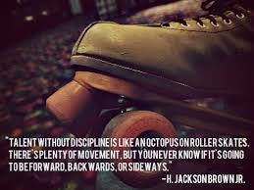
Talent without discipline is like an octopus on roller skates. There's plenty of movement, but you never know if it's going to be forward, backwards, or sideways. H. Jackson Brown, Jr.

There’s a lot of research that suggests when children show promise & talent people start to lavish attention and praise on them which motivates them even more to keep trying. It’s a self-fulfilling positive prophecy.

The Blueprint for Raising Happy, Confident, Resilient Children. The Crucial ‘C’s

Many years ago, research was carried out to discover why some children become ‘successful’ in the broader sense, and others don’t. The findings were very clear regarding those differences: children who succeed have close relationships with others, particularly their immediate family, feel valued in their communities & have a sense of control over some aspects of their lives. While children who are in trouble feel isolated, useless to society and powerless.

The children in trouble are missing four important necessities to manage life’s challenges.

- They are missing feeling connected to others, whether that is their family or the community.
- They are missing feeling capable to take care of themselves.
- They are missing feeling valuable, that they count and that they matter & they make a difference.
- They are missing courage.
These four fundamentals are needed for children to feel that they can meet and manage the challenges of life.

What the Crucial ‘C’s Give Children.

Feeling that we connect, that we are capable, that we count and that we have courage will go a long way to enhance a positive attitude about life and give it meaning & purpose. By embracing these very simple principles you will transform your parenting & become better at understanding the goals behind your child’s behaviour & their needs because these simple principles will empower you with better ways to raise a happy, confident, resilient child with strong self-esteem & good mental health.

I have simplified the Individual Psychology of Alfred Adler into the CRUCIAL C’s so that we, as parents, can remember and live by these simply guidelines.

If we ensure that our children feel connected, capable, courageous and that they count as valuable human beings, they will take life on and make it work for them. They will develop a ‘Can Do Kid’ mindset & they will have the ability to handle whatever life throws at them. They will have a positive mental attitude and good mental health.

Kids who are brought up with the four Crucial ‘C’s become:

•Responsible
•Productive
•Co-operative
•Self-reliant
•Resilient
•Resourceful
•Contributing
•Happy

Feeling Connected.
We are social beings, and must band together, as our ability to survive both physically and psychologically depends on our ability to connect to others. We move from being helpless babies totally dependent on others, to interdependence with others. This process of moving from total dependence takes a considerable time compared to other animals who walk and take care of themselves far sooner than human beings do. But as infants grow they develop their capabilities away from total dependence towards becoming more independent.

As children grow into toddlers they experiment, make mistakes and learn through trial and error, and the more capable they are allowed to feel, the more self-confident they become.

A teenager who is confident & secure in their belief about belonging to others in their family feels connected so they are able to co-operate because they don’t feel afraid that they’ll be rejected or isolated. They are more resilient to peer pressure and being drawn to gangs and the wrong crowd to feel connected.

A child who connects in a constructive, healthy way feels secure, can reach out to others, can make friends and can co-operate easily.

A child who doesn’t feel connected in a constructive way feels insecure, isolated & will seek attention and believe that any attention is better than none, and may be more susceptible to peer pressure

This need for connection was based on research based on studying 12,000 teenagers by the ‘Journal of The American Medical Association’ that found young people who felt connected were less likely to take drugs, smoke, drink alcohol, become violent, or get pregnant. In short, they had better mental health.

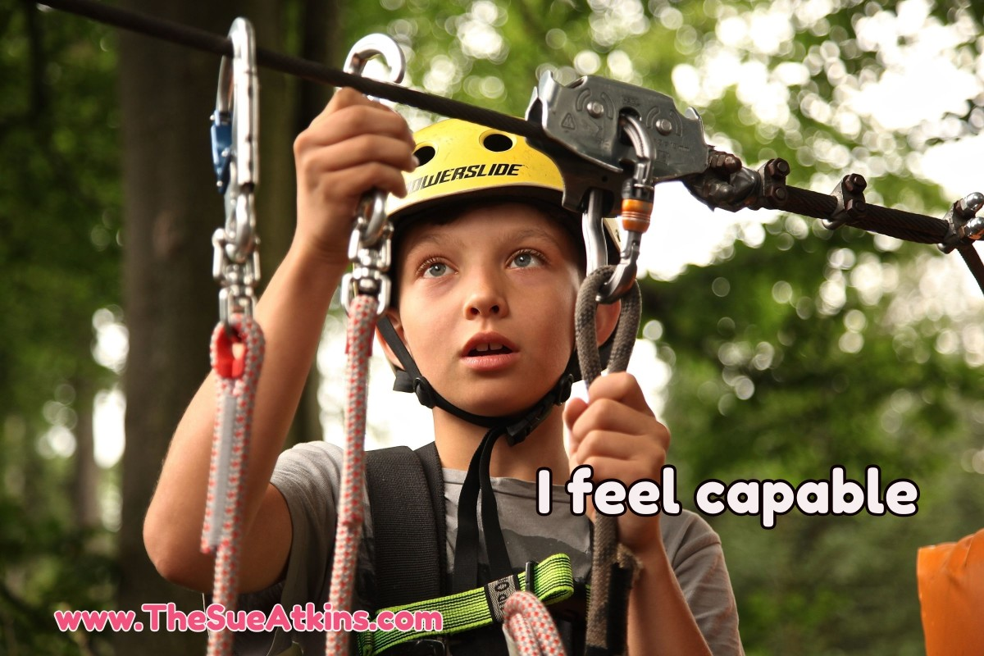

Feeling Competent and Capable.
Toddlers who began life as helpless babies learn to hold their heads up, roll over, stand up & walk. This need to become independent is innate. A toddler doesn’t fall over the first time and decide that walking isn’t for them! They get back up time and time again – needing remarkable tenacity but their need to feel competent and capable is within and driving them forward to succeed.

Children develop their competence and capabilities through being allowed to explore, experiment and make mistakes & they must be given the opportunity to be given real jobs and activities that are meaningful. We live in a busy, hectic, frenetic world and parents are often in such a hurry that they rob their children of the opportunity to ‘struggle’ a little in finding their lunchbox, putting on their shoes or of doing up the zip on their coat.

It’s often easier, and certainly quicker to do it for them, but this mistaken way of helping children may have serious consequences long term.

Children may interpret your failing to trust them to do these things as a sign that you don’t think they can do them. You rob your child of the experience of feeling competent and capable. Unconsciously the message they have received is ‘You don’t think I can do things for myself.’ Basically, you’ve given them the message of ‘No Confidence.’ Added to this their observation of older siblings or grown-ups being more far more competent than they are, your child may unconsciously decide that they won’t even bother to try. That keeps them stuck in dependence. Over time they may learn to resent you or certainly feel inadequate or may even decide to become a Verruca Salt – a spoilt and pampered child who needs ‘staff’ to take care of their every need!

An over-protected child may become overly dependent on others and may be afraid to be alone later in life, make decisions independently or may become so confused that they may ‘boss’ people around to get their needs met!

Teenagers who are encouraged to feel competent and capable develop self-control and become self-reliant. They are able to take on responsibility & have equal, healthy & respectful relationships with others. Whereas teens who are discouraged from feeling competent become risk takers. They are unsure of their own capabilities & they may resist your attempts to guide them – feeling the need to ‘prove themselves.’

While other disempowered teens take a different approach, and resist responsibly – not getting up in the morning unless you wake them, not doing their homework unless you nag them, expecting you to pick up, wash up and basically do everything for them! It’s worth remembering that your exasperation with them is because of your love for them, you have unconsciously disempowered them to take responsibility for themselves. It’s not helpful to beat yourself up if you discover that you have pampered them over the years but it may be time to let them face the consequences of their actions by getting a detention for undone homework or late arrival at school.

A child who sees themselves as capable feels competent, has self-control and self-discipline assumes responsibility and is self-reliant.

A child who feels incapable feels inadequate & they try to control others, seek power & often become defiant and they may become too dependent.

Children who are offered the opportunity to feel competent and capable believe they can do things for themselves and they feel happier.

Feeling Significant – ‘I Count’

We all like to feel that we matter. We count. We make a difference and children are no different.

Toddlers are self-centred as they are not yet mature enough to differentiate themselves from others, but if parents respond to their needs and care for them they feel secure and safe. They can trust the world. They learn that they can count on others.

A baby will soon learn that they are important. That they matter. That they are significant and that they count.

Whereas a baby whose needs are not met may learn that they can’t trust the world and that the world isn’t a safe place and they may not be able to move beyond that self-centred experience.

Children who are encouraged & appreciated learn that they count, that they matter, that they are important, and they feel significant and valued for who they are. Whereas children who are not made to feel significant look for a way to feel valued in more destructive ways. Attention seeking, being unkind to siblings, provoking others and seeking revenge to get their need for significance met.

Teenagers who feel valued become more involved in school or community activities and are conscious that they make a difference and can affect the world for the better. They are less likely to break the rules or avoid responsibility. They behave constructively. Whereas a teen who doesn’t feel that they count, behaves in more destructive ways, becoming sexually active, getting involved in vandalism, gangs or stealing thinking that what they do doesn’t matter.

A child who believes that they count feels valued & believes that they can impact on the world positively.

A child who believes that they don’t matter feels hurt, insignificant and may try to hurt back, seek revenge or decide that making a negative impact is better than making no impact at all.
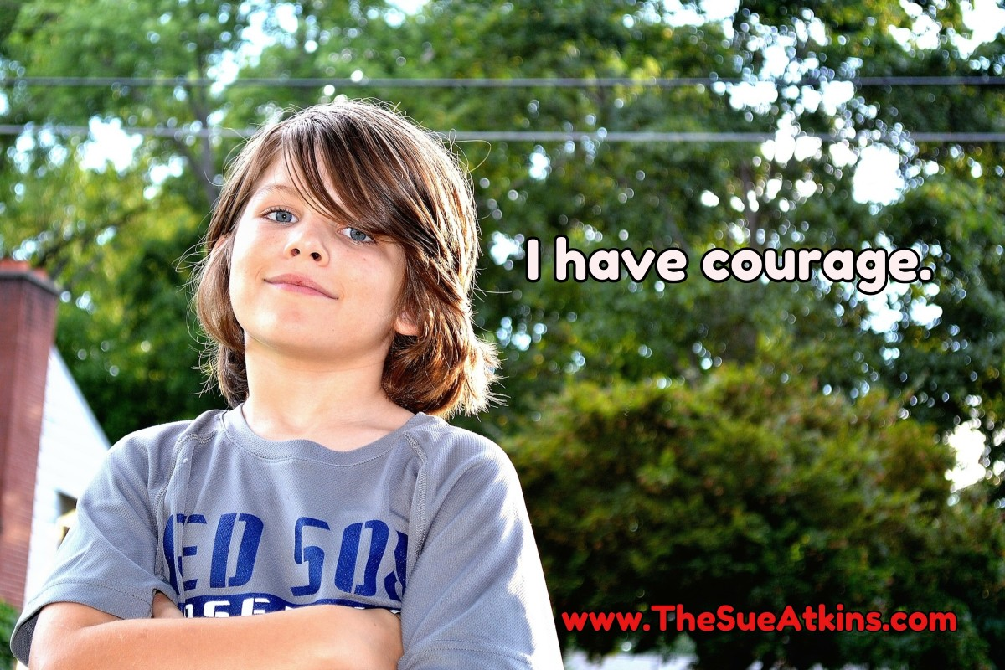
Courage
The Lion in The Wizard of Oz was looking for courage & no wonder as being a human being is tough – it takes courage to ride the ups and downs of life. It’s packed full of good and bad experiences, frustrations, disappointments and challenges. It’s a risky and precarious adventure so developing courage in your children is important.

This one attribute alone was enough for Rudolph Dreikurs, the renown psychiatrist and parent educator, to say that if we could give children only one quality to help them succeed and manage life it would be courage.

Toddlers are amazing as they show courage in everything that they do from learning to walk, to learning to talk, to learning to climb and to balance, to learning how to open doors & put on wellies, they show courage as they go from one mistake to another until they master that skill. That takes courage.

Think back on your life – it took courage to go to playgroup, start school, go to secondary school, to leave home, start a new job or get married. Feeling the fear and doing it anyway as the Susan Jeffers book encourages. Babies, infants and toddlers experience frustration, disappointment, hurt, anger and fear just like we do and I admire them so much for their tenacity to keep going. But that courage stands them in good stead for the whole of their lives.

As Franklin D. Roosevelt is quoted as saying, ‘Courage isn’t the absence of fear but the ability to overcome it.’ Children without courage focus on what they can’t do. They give up and avoid situations. They miss out on life’s wonderful experiences through fear.
A child with a ‘Can Do’ attitude who shows courage feels hopeful & optimistic and is willing to try and have a go. They develop tenacity and resiliency. They embrace life and all its opportunities.

Becoming a teenager is a challenging time – it a time of confusion & uncertainty as your teen feels precariously posed between childhood and adulthood. That’s why it’s a constant feeling of three steps forward and five steps back at times.
There’s the struggle for independence, peer pressure, understanding their sexuality, being surrounded by so many dilemmas from recreational drug taking to gaming to online porn to the desire to fit in and not stand out and be different. It’s a tough time and they need courage to navigate the choppy waters of the teenage years – hence the title to my CD.

Teens who don’t have courage blend into the background in school, afraid to put their hand up in class, join the Netball Club, take up Taekwondo, learn to play basketball or tap dance. They’ll find it hard to resist the pressure to drink alcohol, take drugs, or join in with unhealthy choices as they won’t be brave enough to say ‘No.’

A child who is encouraged to be courageous feels the fear and does it anyway, they feel equal, confident, hopeful and brave to try. They face challenges and become resilient and they can stand alone if they have to. They believe that they can handle whatever life throws at them.

Whereas a child who lacks courage can’t get over their fear, it controls them and they feel defeated, hopeless, discouraged and inferior. They want to blend in and may not resist the crowd.

To Encourage Risk, Failure & Setbacks Be A Positive Role Model
Creating ‘Cotton Wool Kids’ who are afraid to try, afraid to take calculated risks, and afraid to make mistakes results in children giving up too soon.
Just for this week notice how you handle your own mistakes. Then notice how you handle it when your kids mess up, make mistakes or get things wrong.
Do you rush in to rescue?
‘Pause to Ponder’ making a deliberate mistake in front of your kids and modelling a more empowering way to handle it free from shame, embarrassment or anxiety so they can learn from you.
For example: Leave an important file at work that you meant to bring home and say ‘Oh no, I left that important file at work. I must remember to write a reminder on my phone so I won’t forget it tomorrow night.’

Styles of Parenting That Nurture Grit
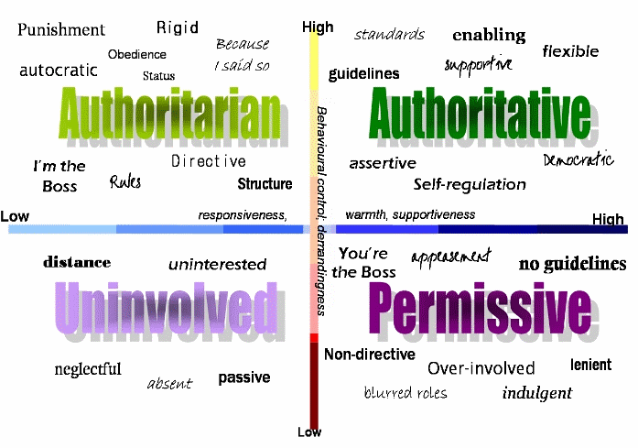
The four parenting styles have distinct names and characteristics:

•Authoritarian or Disciplinarian.
•Permissive or Indulgent.
•Uninvolved.
•Authoritative.

According to research the style that produces the best outcomes in child development is the authoritative style of parenting.

From Argentina to China, from the United States to Pakistan, the authoritative parenting style is consistently associated with superior outcomes (Steinberg 2001).
Based on research, children of authoritative parents:
•have a lively and happy disposition
•are self-confident about their ability to master tasks.
• have well developed emotion regulation
• have developed good social skills
•are less rigid about gender-typed traits (especially sensitivity in boys and independence in girls)

Children who are brought up with firm, fair, consistent boundaries with reasonable limits around their behaviour, who are supported & surrounded by love, who are encouraged, nurtured and feel important & are expected to keep going & to overcome their fears, develop grit.
Coupled with observing you as a positive role model showing grit and determination around your own goals, you now have a simple formula for success

What is the Authoritative Parenting Style?
An authoritative parent to tries to direct their child’s activities in a rational, balanced way. They encourage verbal give and take & they share with their child the reasoning behind their decisions.

Authoritative parents:
•listen to their children.
•encourage independence.
•place limits, consequences, and expectations on their children’s behaviour.
•express warmth and nurturing.
•allow children to express opinions.
•encourage children to discuss options.
•administer fair and consistent discipline.

What Activities Encourage Grit in Children?
The question on the minds of most parents is probably this: how do we encourage grit in our children?
Unfortunately, grit isn’t a neat little package that you can wrap up in a box and hand over to your child. It’s complicated.

To build grit work on the 5 characteristics of grit:
1.Courage
2.Conscientiousness
3.Follow Through
4.Resilience
5.Striving for Excellence

Then focus on developing
1.Having a Growth Mindset
2.Developing Self-Control
3.Committing to Deliberate Practice
4.Following “The Hard Thing” Rule

‘Talk and Teach’ Your children through a positive mindset and develop:

- Positive Emotion - the ability to be optimistic and view the past, present, and future in a positive perspective, experience joy, inspiration, gratitude, hope, pride, serenity, amusement, curiosity, awe, love.
- Engagement – the ability to participate in a project that entirely absorbs us in the present moment.
- Relationships – the need for connection, love, intimacy, and a strong emotional and physical interaction with others.
- Meaning – having purpose in life.
- Accomplishment – having goals and ambition that give us a sense of satisfaction when we achieve them.

Encourage Grit with Early Failure

While it is important that our children learn to weather adversity and emerge triumphant, they also need to learn how to manage failure. Kids who cruise through life winning all the time will struggle to pick themselves up again when they experience their first real failure. They grow up to be “fragile perfects” – vulnerable high achievers who know how to succeed but not how to fail.

And that’s the problem. Everyone will experience failure at some point in their lives. They need to know how to bounce back from it. The longer it takes for this first failure to happen, the harder it is to learn how to bounce back. That’s often what happens with “fragile perfects” – by the time they get their first failure, they’ve been on a winning streak for such a long time that it can be devastating.

One of the difficulties with introducing failure is doing it in a way that is natural. We don’t want to force our children into an impossible situation just to make sure that they get the experience of failing. However, they do need to feel the discomfort of standing on the precipice of potential failure and experience the occasional setback that will help them build resilience for future obstacles. We can do that by getting them involved in some healthy competition.

Encourage Grit Through Experience
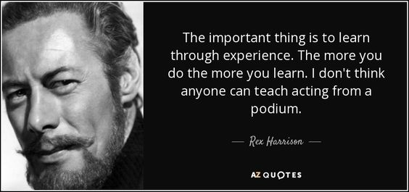
Probably the most frustrating thing about grit is that it is difficult to teach through words alone. You can’t talk your kids into “grittiness”, they have to experience it for themselves and make their own connections. The ‘aha!’ moment will only arrive when something happens to them. Grit is unfortunately one of those things in life that must be learned the hard way.

Simple & Quick Ways to Encourage Grit
Sport
A study comparing athletes to non-athletes revealed that athletes have higher levels of mental toughness compared to non-athletes. Since we have sort of equated mental toughness with grit, we can generalise that getting children involved in sports is only one potential avenue for building grit.

Competition
Healthy competition provides a natural environment to experience failure. Even if it isn’t competitive sports, any other form of competition can be good, too. Playing chess, maths challenges, quizzes all teach winning and losing and the tenacity and confidence to try.

Outward Bound Camps
Joining Scouts, Girl Guides, doing the Duke of Edinburgh Awards or going on adventure camps or on hiking expeditions that use outdoor challenges all help to develop that ‘undefeatable spirit’ & build grit as they develop independence, confidence, assertiveness, and the belief that what happens in life is largely under your control.

Extra-curricular Activity Follow-Through
Angela Duckworth’s research revealed that you could identify gritty kids based on the following:
•They were involved in extra-curricular activities for a considerable time. It could be any activity – sports, music, volunteer work, a part time job, academic activities, etc.
•In that time, they had made advancements in their activity – e.g. being awarded “employee of the month” in an after-school job or a sense of moving forward and doing well.
•The more significant the advancement, the grittier they were.

It doesn’t matter what activity your child chooses as long as they stick to it for a good length of time and make progress. The practice of sticking to the activity and advancing in it is an opportunity for your child to exercise their grit muscles and make them stronger. In essence, this is what the whole “hard thing rule” is based on.
So, there you have it – not perfect answers but at least a direction to work towards.

Ways to Encourage Passion in Children
We have to encourage passion for life and curiosity.
Here’s how we do this:

- Model big dreams in your own life. When we live our lives as a great adventure, we give our kids permission to do the same.

- Encourage their bucket list. Introduce your kids to the concept of a ‘bucket list,’ and invite them to make their own. I’ve worked with lots of families and children & some awesome moments and memories have been made as a result of these lists. Have fun creating ‘Dream Boards.’

- Give them free time. This freedom will allow them the space they need for self-discovery. As the parent, you are the only person that can protect them from the hectic pace that is now normal in most households. Opt out of the over scheduling rat race and give your kids the gift of TIME. Hold the space for them to dream and discover their passions.

- Allow them to tinker. When given the time, kids may choose to pursue interests that don’t have a clearly defined outcome. Be okay with this. Challenge yourself to value these exploratory efforts as worthwhile. It’s important to keep an open mind to where their interests lead them, especially when you don’t initially see how it’s beneficial.

- Introduce BIG dreamers. These can be people you know, those in your community and people from history like Martin Luther King Jr., Amelia Earhart, Elon Musk. These inspirational dreamers help teach children that anything is possible, no matter what the obstacle.

- Live life as a daring adventure. To create an environment that fosters dreaming big, we need to break out of the ruts that can consume our everyday family life. Be spontaneous. Get messy. Have dessert first every as a surprise, have a ‘Barbarian Spaghetti’ dinner without any plates or silverware, build a den in the garden and sleep out one night. Use surprise to break free from the ruts that we all get into. There are a million different rut busters out there and, as a parent, you must employ them on a regular basis to keep life fresh and exciting amidst the business.

In a time when kids are seemingly growing up too fast, it’s essential to consider the importance of their childhood dreams. Fostering an environment in which their dreams are valued will help them carry on that free spirit and youthful passion into adulthood – and the world just may become a better place.

- Provide opportunities. When your children attempt new things, they find hidden talents. They find activities that they enjoy and skills that become valuable throughout their entire lives. Provide opportunities for your children to find these talents, skills and passions. Encourage your children try new sports, extra-curricular activities, jobs, classes and more. Be encouraging and helpful as they try to find things they love to do. But find that balance of not doing too many activities at once because it can become overwhelming and stressful and will most likely result in a quitter instead of an achiever.

- Praise your child. Let your children know when you are proud of them. Let them know when they do something right. Your praise and recognition mean a lot to a child. It can build them up, even when they have low confidence and self-esteem. When children receive praise, they are more likely to continue trying because they want your approval & enjoy your time and attention. Praise is a simple way to encourage and a way to help boost up your child’s confidence and self-worth. Be sincere, be specific and remember to praise their efforts not just their achievements. Developing grit is about developing your child’s character not solely about the results of their maths test!

- Praise the effort, not the result. This one can't be repeated enough, especially in our ultra-competitive, testing culture that places an extraordinary emphasis on grades from primary school up through college.

- Support your child’s decisions
Your children are individuals. They have their own loves and passions and they won’t always choose hobbies, sports, activities and even careers that you choose.

Be supportive of your child’s decisions. Your support shows your love and your willingness to help them in whatever activities they pursue. When you don’t show that support, your children will have a more difficult time finding activities they enjoy and want to continue. When challenges and failure come along, your child will be more likely to quit and give up than push forward and reach his or her potential.

- Set goals together. When your child is a goal-oriented & focused, they are more willing to reach their potential. Start off by setting small simple goals with your children to motivate and drive them. You can even use incentives and be their own personal cheerleader as they learn to set goals and learn about what it takes to accomplish them. Then encourage them to think bigger. No matter who your child is, or whether they have additional needs, they have much potential. Children can accomplish things that may seem out of reach, they may just need a little help. Be there for your children and watch them achieve their full potential.

Simple Ways to Develop Grit

- Read Books About Grit

- Oh, The Places You'll Go! by Dr. Seuss

As my daughter and I read this book, I realized that it’s truly about the importance of staying determined. The reader is told that she is will fall on her journey, and the book directly challenges her to get back up. Understanding that failure is inevitable is a key to cultivating resilience. With rhymes and illustrations, Dr. Seuss teaches readers that what really matters is how you respond to those failures.

- The Hugging Tree: A Story About Resilience by Jill Neimark

Though the book’s tree is alone on a cliff, it figures out how to work through challenges and stand tall. Using the tree's struggle as a metaphor for maintaining one's solid foundation even through difficulty, this book illustrates resoluteness for the reader — and includes a note for parents at the end by an education professor who offers tips on teaching grit.

- A Chair for My Mother by Vera B. Williams

Celebrating 30 years in print, this Caldecott Honor book tells the story of a family recovering after they lose their home to a fire. By saving money and working together, the child, mother, and grandmother find ways to reassemble their household.
- Sheila Rae, the Brave by Kevin Henkes

This story is all about facing fears. Sheila Rae isn’t afraid of anything and she wants those around her to know that. But one day, that bravado puts her in a tricky situation, and she finds herself relying on others for help. My daughter adores the mouse illustrations in Henkes's work.

- Chrysanthemum by Kevin Henkes

Chrysanthemum loves her name but is devastated when her classmates use it to tease her. She learns to cope with the name-calling and approaches her identity in ways that overcome the mocking she endures. She is able to get back to a place where she loves her name that uses "half the alphabet."

- The Name Jar by Yangsook Choi

When kids are young, having a unique name can become fodder for teasing. How does a child learn to be resilient in the face of taunts that stem from the most basic element of her identity? Afraid of what others may say about her Korean name, Unhei tries to change her identity — until she realizes that her name is not something to hide from. Instead it’s something to be celebrated.

- The Short Tree and the Bird That Could Not Sing by Dennis Foon

Neither of the main characters in this book fits the standard ideal of their world — the tree in the book doesn’t tower over all, and the bird cannot belt out a beautiful tune. Together, the two find ways to bounce back from feeling less-than.

- The Name of the Tree: A Bantu Tale Retold by Celia Barker Lottridge

This group of animals needs to find food, and their only option is the fruit of a tree with branches that are too high for them to reach! They must work together and persevere as they explore ways to get the food they need. This one is fun to read aloud thanks to its repetition.

- The Empty Pot by Demi

The emperor calls on all the children of the kingdom to grow the most beautiful flowers they can. Ping wants to impress him, but even though he cares for his seed every day, nothing grows. Ping must face the emperor, embarrassed by his “failure.” Ultimately, he is rewarded when his persistence and tenacity are recognized more than his lack of production.

- Princesses Are Not Perfect by Kate Lum

"Perfection" and "princess" often go hand in hand, which is why I struggle so much with the idea of presenting my daughter with princess images. But she loves them. So why not offer her this book, which shows her that even princesses fail and need each other sometimes?

- Talk About Grit – chat about your own life and how to handle life’s ups and downs positively. Encourage Your Child to Conduct “Grit Interviews” Children learn pessimism or optimism from the adults in their lives, so providing opportunities for your child to learn from positive, gritty adults is key.
Your child can interview grandparents, neighbours, teachers or other acquaintances who have worked hard toward a long-term goal.

- Share Examples & Stories of family, friends and famous people – showing tenacity and overcoming hurdles and setbacks – the ordinary and every day. (e.g. Invictus Games)

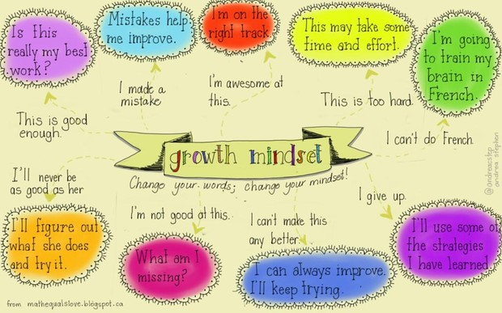
- Help Kids Develop a Growth Mindset –

- Reframe Problems
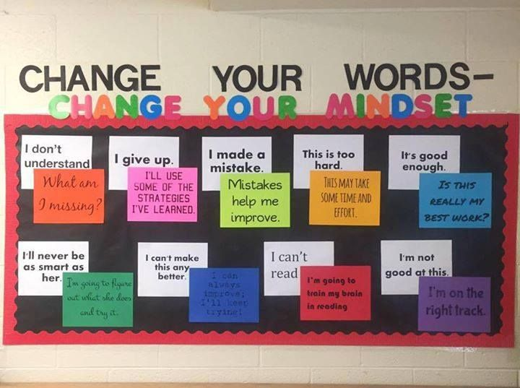

- Adopt These 7 Positive Characteristics.

Zest – is having an enthusiastic and energetic attitude to life.
Grit – is having perseverance and a passion for achieving a long-term goal
Gratitude – is feeling grateful & thankful for all we have.
Self-Control – is the ability to manage your actions, feelings and emotions yourself.
Curiosity – is your eagerness to explore new things with an open mind.
Optimism - confidence in a future full of positive possibilities.
Social Intelligence – is understanding the feelings of others and adapting your actions accordingly
- Live Grittily – bounce back – it’s not how far you fall it’s how high you bounce back!

- Foster Safe Circumstances That Encourage Grit
Never mistake engaging, fun or even interesting for easy.
We don't jump up and down when we tear off a piece of paper from a pad because "I did it." No one celebrates easy, but everyone celebrates championships and winners because those achievements take grit. We need to create more circumstances to help kids to develop grit before they can "have it all and have it NOW"
- Create simple habits that are small steps towards change.

- Acknowledge the Sacrifice That Grit Requires. Grit takes time. We are what we do, and if we try less, work less, then we will learn & achieve less.

- Discuss When You Need Grit and When You Need to Quit
There is a time for grit and a time to quit. There are times when it's OK to quit something that just isn’t within your range of talents, or physical ability. Worthy tasks deserve persistence. But there are tasks that would be better left altogether or to in a different time of your life. Sometimes you have to let go of something good to grasp something great. Children need discernment to know when they need grit and when it may be a time to quit. It’s about teaching that fine line and that sense of balance.

Self-Control and Grit:
Other than talent and opportunity, what makes some people more successful than others? One important determinant of success is self-control—the capacity to regulate attention, emotion, and behaviour in the presence of temptation.

Play games that help kids practice self-control

Any time we ask kids to play by the rules, we’re encouraging them to develop self-control. But some games are more challenging than others. Here are some games designed to give your kids a self-regulation workout:

Here are 10 FUN games that require no preparation or equipment to practice and learn self-regulation skills:

- Red Light, Green Light – kids move on the green light and stop on the red light. Don’t get caught moving on the red light.

- Mother May I – one child is the leader. The rest of the children ask: “Mother May I take….” a certain number of steps, hops, jumps or leaps to get to the leader. The leader approves or disapproves.

- Freeze Dance – turn on music. When music stops children must freeze.
- Follow My Clap – The leader creates a clapping pattern. Children must listen and repeat.

- Loud or Quiet – Children must perform an action either loud or quiet. First pick an action i.e. stomping feet. The leader says Loud and the children stomp feet loudly.

- Simon Says – Children must perform an action only when the leader says, “Simon Says do…”. For example, if the leader says, “Simon Says touch your toes” and all the children touch their toes. If the leader says, “Touch your toes”, no one should touch their toes.

- Body Part Mix Up – The leader will call out body parts for the children to touch. For example, the leader calls out “knees” and the children touch their knees. Create one rule to start. Each time the leader says “head” touch your toes instead of your head. This requires the children to stop and think about their actions and to not just react. The leader calls out “knees, head, elbow”. The children should touch their knees, TOES and elbow. Continue practicing and adding other rules to change body parts.

- Follow the Leader – The leader performs different actions and the children must follow the actions exactly.

- Ready, Set, Wiggle – The leader calls out Ready…Set…Wiggle and everyone wiggles their bodies. The leader calls out Ready…Set…Watermelon. No one should move. Leader calls out Ready…Set…Wigs. No one moves. Leader calls out Ready…Set…Wiggle.

Everyone wiggles again. You can change this to whatever wording you want. The purpose is to have the children waiting to move until a certain word is said out loud.

- Colour Moves – Explain to the children that they will walk around the room. They are to move based on the colour paper you are holding up. Green paper means walk fast, yellow paper means regular pace and blue paper means slow motion walking. Whenever you hold up a red paper they stop. Try different locomotor skills – running in place, marching, jumping, etc.

Here are a few suggestions on how to help kids learn to control their behaviour ages and stages

Up to Age 2
Infants and toddlers get frustrated by the large gap between the things they want to do and what they're able to do. They often respond with temper tantrums. Try to prevent outbursts by distracting your little one with toys or other activities.

Ages 3 to 5
Teach your child time to calm themselves down, teach them to breathe deeply and slowly, stamp their feet or move away from what’s annoyed them. Ask them what helps them feel better. This helps children to improve their sense of self-control. Remember to praise your child for not losing control in frustrating or difficult situations with a smile, hug or words of encouragement.

Ages 6 to 9
As children go to school, they are able to understand the idea of consequences and that they can choose good or bad behaviour. It may help your child to imagine a stop sign that must be obeyed when they feel themselves ‘losing it’ or for them to imagine pressing an imaginary ‘Pause Button’ like on your remote control zapper to freeze frame everything for a moment while they take a physical step back, as this helps them to think about a situation before responding. Encourage your child to walk away from a frustrating situation for a few minutes to cool off instead of having an outburst. Praise kids when they do walk away and cool off — they're more likely to use those skills again.

Ages 10 to 12
Older kids usually understand their feelings better. Encourage them to think about what's causing them to lose control and then analyse it. Explain that sometimes situations that are upsetting at first, don't always end up being totally awful. ‘Talk and Teach’ your kids to take time to think before responding to a situation. Compliment them as they use their self-control skills.

Ages 13 to 17
By now kids should be able to control most of their actions. But remind teens to think about long-term consequences. Urge them to pause to evaluate upsetting situations before responding and talk through problems rather than losing control, slamming doors, or yelling. If necessary, discipline your teen by taking away certain privileges to reinforce the message that self-control is an important skill. Allow him or her to earn the privileges back by demonstrating self-control.

Finally

It’s encouraging to know that grit, one of the most important indicators of success, is entirely teachable.

I hope these simple ideas will help your child build the passion and perseverance they need to succeed in school and in life.

This e-book was created with love by Sue Atkins

