Sue’s Emotional Rucksack

Have You Filled A Rucksack Today?

All day long children are carrying round an invisible rucksack.
You can’t see it, but it’s there.
Children carry an imaginary rucksack that needs to be filled daily with T-I-M-E, love, affection, attention & security.
When children’s rucksacks are full, they feel safe, secure, confident, valued and happy. They have good self-esteem & are resilient to life’s ups and downs.
They feel connected to you and your family. They don’t feel the need to constantly attention seek, play up or misbehave to get your time & attention as their emotional needs are being met.
Over time they learn how to fill up their own emotional rucksack as they develop their own resilience.
This all nurtures your child’s mental health and wellbeing.

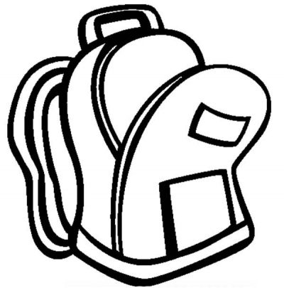

When a child’s rucksack is empty, they feel stressed, anxious and worried.

Children with an empty rucksack deal with it in a number of ways
- they may try to steal from other people’s rucksacks
- misbehave to get attention which shows that they need a top up
- become angry, jealous or impatient
- become rude & aggressive
- throw tantrums
- think they have to fight or compete to get a refill

What fills a rucksack
- time
- kind words
- play
- friendship
- one-on-one time
- love and affection
- connection
- succeeding
- doing what they love to do or what they choose to do

What empties a rucksack:

- stress and strain
- rejection by peers
- loneliness and isolation
- shouting and punishment
- failing
- tiredness
- doing what they're forced to do or they hate to do

Rucksack filling is fun and easy to do.
It doesn’t cost any money.
It doesn’t take much time.
When you are a rucksack filler you are teaching your child that they are important and special and you make your home a better place to be.
Rucksack filling makes everyone feel good
At the end of a day simply get into the habit of asking yourself
‘Did I fill a rucksack today?’
It’ll keep you all on track towards a happy home with a happy child.

Make sure your child's Emotional Rucksack is filled up every day!

